iConnectDBA User Guide

# Introduction

iConnectDBA is a small utility with the following functions

* Compare and update database structures
* Archive from live iConnect database to archive databases
* Execute simple SQL statements against the target database.

Setting up of iConnect DBA requires you to either run it on a machine set up for iConnect, or setup the basic paths, files and database settings as if you were running iConnect on the machine. iConnectDBA does not use the hive, so hive settings can be left unchanged/default.

The following sections summarise the use of each of the three main functions.

# Activity Log

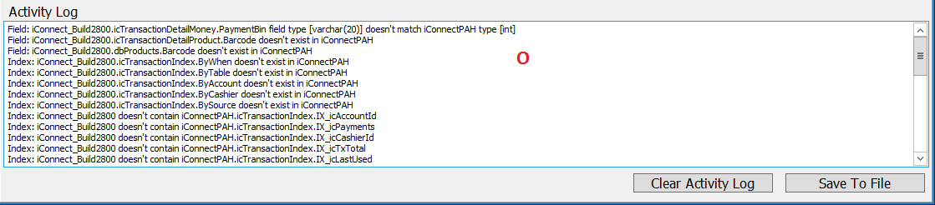

Each of the functions retains an activity log at the bottom showing various activity, and errors that may occur. This can be cleared and/or saved to a local file via the buttons at the bottom.

# Database Structure

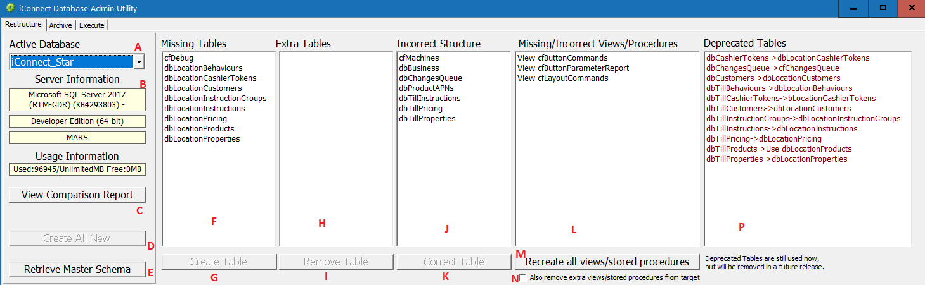

Summary of functions:

1. Active Database selects which database to act upon, iConnect is defined to be the ‘live database’ and other databases are auxiliary, special or archive databases.
2. Shows various information about the database, including the version and edition. Note that EXPRESS EDITION has a size limit, which is shown under usage information.
3. View Comparison Report shows a summary of the differences between the master schema (dbschema.xml in the iConnect config directory) and the selected schema. Under normal use this should be provided for you.
4. Create All New allows you to create an entirely new database schema in an empty database. You will need to create the database schema using the SQL Management studio, and assign any user permissions using the security functions within that tool. Once you have an empty database on the server, then you can use “Create All New” to create all tables, views and stored procedures with one button.
5. Retrieve Master Schema allows you to retrieve the master schema document (dbschema.xml) from a known good database (selected via Active Database). Do not use this unless you know what you are doing, a warning will be offered if you do press this and the existing dbschema.xml file will be overwritten.
6. Missing Tables shows a list of tables missing from the selected database, that should exist (based on the master schema).
7. Create Table creates the missing table assuming one is selected above, if no table is selected then this button will be greyed out.
8. Extra Tables shows a list of tables in the selected database, that should not exist (based on the master schema).
9. Remove Table removes the extra table assuming one is selected above, if no table is selected then this button will be greyed out.
10. Incorrect Structure shows a list of tables in the selected database which have an incorrect structure (based on the master schema).
11. Correct Table attempts to correct the structure of the given table by creating a new table with the correct structure, copying the data across and removing the original table. Note that this can fail in rare circumstances (especially on very full databases). If no table is selected above then this button will be greyed out.
12. Missing/Incorrect Views/Procedures shows a list of views that are either incorrect, or missing. It does not show extra procedures/functions as sometimes these are created for local purposes.
13. Recreate All Views/Procedures removes and recreates all stored procedures and views according to the definitions stored in the master schema file.
14. Also remove extra views/procedures from target will, if checked cause the above recreate button to also remove additional views/procedures in the target that are not in the standard schema. Note that this should be used with caution as local sites may have views/stored procedures used for local purposes. Additional views/procedures cause no adverse effects and take up negligible amounts of storage.
15. Activity log shows progress of changes to the database requested above.
16. *NEW* Deprecated Tables shows a list of tables marked for future removal, along with the table the data in these tables will be migrated to.

# Archive

One of the functions in an iConnect archive database is the ability to archive data up to a given date from the live. This utility makes this process straight forward as it creates the new database, names it based on the selected date, creates a full schema based on the master schema setting, then calls the appropriate routing in the archive database to archive the data and remove it from live. If any errors occur during the process, the original live database will remain unchanged, and the new database will exist but have no data in it. To repeat after diagnosing such an error, the archive database with the failed archive needs to be removed via SQL Management Studio.

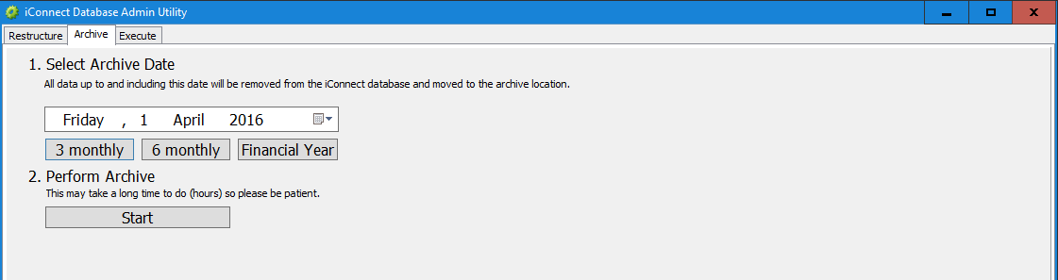

Step 1 is to select a date representing the last date which you want removed from the live database and inserted into the archive. The date used to compare against is the business date (that is – 3AM Monday will be deemed a Sunday), and the transaction’s end date (finalise/complete date/time).

The three presets are for common arrangements, each assumes you doing period archives of a certain length. Each will retain a complete + partial period of that duration in the live database and archive older. For example if you press ‘3 monthly’, if it is April 16th today, then it considers you wish to keep the first quarter (Jan-March) and the current partial quarter (April) and archive all transactions on or before 31st December last year. Similarly for the 6 month and 12 month (financial year boundaries).

Note that selecting a preset will merely set the date/time in the entry box. If you decide not to use presets, or you wish to adjust the preset date then you can use the dropdown calendar to select the date you wish to use.

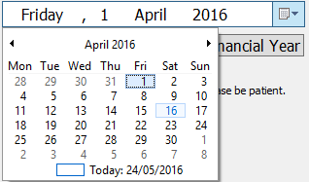

Step 2 is to press ‘Start’, the main thing to note here is that his process can take a very long time on large archives. Due to the nature of ensuring that no data is lost, the process is somewhat slow. A number of hours could elapse before you receive any response, status or errors.

# Execute

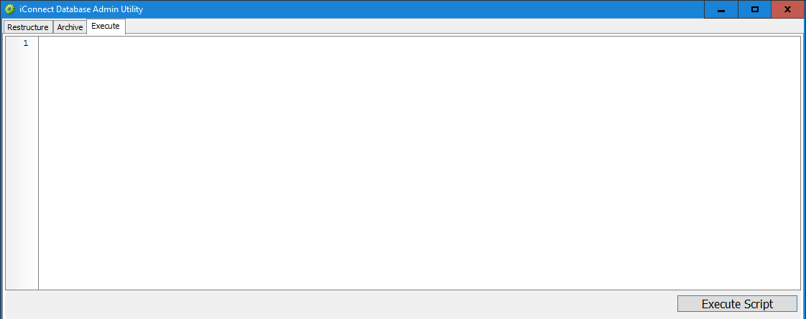

The execute window allows you to execute simple SQL statements that don’t return a result set without having to go to SQL Management Studio. The query will be executed on the currently selected database when you press ‘Execute Script’, errors will be reported in the activity log. No other information other than success or error information will be returned.

*NEW* Result Grid is returned if you execute a select query that returns a dataset – for example:

